**‘Parking Management System’ A WEB APPLICATION**

**A Software Engineering Project**

**By**

**Dawa Lama (7150/16)**



**Submitted to:**

**Indra Pc**

**Department of Computer Science**

**Kantipur College of Management and Information Technology**

In partial fulfillment of the requirements for the Course

Management Information System

Mid Baneshwor, Kathmandu

August 2019

**PREFACE**

The proposed project is a parking management system that provides customers an easy way of reserving a parking space online. It overcomes the problem of finding a parking space in commercial areas that unnecessary consumes time. Hence this project offers a web based reservation system. This project mainly uses html, css and php programming language. The report is organized into four chapters which includes introduction, requirement and design, development and testing, and conclusion.

**ACKNOWLEDGEMENTS**

The completion of a project involves valued contributions from a number of persons. We would like to thank to our college management for providing us this golden opportunity. We remain grateful to our lecturer Mr. Indra P. C. and project instructor Mr. Roshan Rijal for the support and guidance in the development of the system. And thanks to our colleagues for the successful completion of the project.

Contents

CHAPTER 1 6

INTRODUCTION 6

1.1 Existing System Introduction 6

1.2 Disadvantages of Existing System 6

1.3 Characteristics of Proposed System 7

**1.4** **Limitations of Proposed System** 7

CHAPTER 2 8

REQUIREMENT AND DESIGN 8

2.1 Requirements 8

2.2 Design 8

2.3 Relational Database Tables 9

Server Side Database Tables 9

2.3.1 Table Admin 9

2.3.2 Table Vehicle Category 9

**2.3.3 Table Details of Vehicle** 10

CHAPTER 3 11

DEVELOPMENT AND TESTING 11

3.1 Login Form 11

3.2 Dashboard 11

3.4 Vehicle Registration 12

3.5 Outgoing vehicle 13

3.6 Print Receipt 14

3.7 Search vehicle by parking number 14

15

3.8 Change password 15

CHAPTER 4 16

CONCLUSION 16

# CHAPTER 1

# INTRODUCTION

Current scenario of Kathmandu valley parking management is haphazard and chaotic. Public are facing different problems like lack of parking spaces, unmanaged and unsystematic parking causing traffic jam, parking their vehicles at risk, etc. Different parking management should focus on providing systematic and organized parking spaces for their customers.

“Parking Management System” is a web application which is a technical solution which provides a systematic way of reserving the parking space for the user and allowing user to choose specific time of parking and also viewing the total fees of parking lot. The main purpose of developing this app is to provide customers an easy way of reserving a parking space online without any difficulties.

## 1.1 Existing System Introduction

The public of Kathmandu city are facing many problems like lack of parking spaces in commercial and public areas, compelled to pay heavy fees for parking space, no guarantee of safety for the vehicles and parking vehicles haphazardly.

The parking service provider follows traditional and manual way of service without any system, management and records of parking. They use the ticket system where no specific time is provided and no records are kept.

## 1.2 Disadvantages of Existing System

1. **Not user friendly:** The existing system is not user friendly.
2. **Costly:** ​The existing system is more costly as the management must print thedocument or phone the customer.
3. **Time consuming:** All process is done manually.

## 1.3 Characteristics of Proposed System

1. **User friendly:** The proposed system is user friendly because the user can book their parking space sitting at their home at any time.
2. **Economical:** The cost required to operate this system is low compared to the cost ofprevious system. This system uses the resources which are already in the management.
3. **Time saving:** This system saves the time of both user and management section as all the activities is carried out in web application.
4. **Proper allocation of Resources:** The use of the proposed system makes the properallocation of resources like manpower, technological resources etc. of the management.

## **1.4** **Limitations of Proposed System**

1. The application is web based only and not applicable for android and ios user.
2. 24 hour Internet access is required to run smoothly and effectively.
3. The online payment feature is not available.

# CHAPTER 2

# REQUIREMENT AND DESIGN

## 2.1 Requirements

**What system do??**

* Our system allows the user to enter the vehicle category and register parking space for the specific time for the specific vehicle.
* Dashboard to view the number of entries of vehicles of past 7 days.
* Entries of incoming and outgoing vehicles to manage the vehicles.
* User can view and print the details and entries made in the system.

## 2.2 Design

The design of the application is shown through Data flow diagram. It is the graphical representation of how the system works. The DFD of ‘KCMITians’ is shown below which provides the clear picture of how the application works.

**Data Flow Diagram**

Request for login, delete login session, reservation update category of system with parking number vehicle, ingoing and view and print the parking details outgoing vehicle

User

Admin

Application

Details of user, Details of vehicle, phone

transaction Number, Name and number plate

## 2.3 Relational Database Tables

## Server Side Database Tables

## 2.3.1 Table Admin

|  |  |  |  |
| --- | --- | --- | --- |
| S. No | Field Name | Data Type | Description |
|  |  |  |  |
| 1 | Id | Integer | Stores id of the admin |
|  |  |  |  |
| 2 | Admin Name | Varchar | Stores name of admin |
|  |  |  |  |
| 3 | Username | Varchar | Stores username of admin |
|  |  |  |  |
| 4 | Mobile Number | Varchar | Stores mobile number of admin |
|  |  |  |  |
| 5 | Email | Varchar | Stores email of admin |
|  |  |  |  |
| 6 | Password | Varchar | Stores Password set by admin |
|  |  |  |  |
| 7 | Admin Reg Date | Varchar | Stores registration date of admin |
|  |  |  |  |

## 2.3.2 Table Vehicle Category

|  |  |  |  |
| --- | --- | --- | --- |
| S. No | Field Name | Data Type | Description |
|  |  |  |  |
| 1 | Id | Integer | Stores id of the vehicle category |
|  |  |  |  |
| 2 | Vehicle Category | Varchar | Stores categories of vehicles |
|  |  |  |  |
| 3 | Creation Date | Varchar | Stores date of the entries made. |
|  |  |  |  |

## **2.3.3 Table Details of Vehicle**

|  |  |  |  |
| --- | --- | --- | --- |
| S. No | Field Name | Data Type | Description |
|  |  |  |  |
| 1 | Id | Integer | Stores id of the vehicle |
|  |  |  |  |
| 2 | Parking Number | Varchar | Stores parking registration number of vehicle |
|  |  |  |  |
| 3 | Vehicle Category | Varchar | Stores category of vehicles |
|  |  |  |  |
| 4 | Vehicle Company Name | Varchar | Stores vehicle company name |
|  |  |  |  |
| 5 | Registration Number | Varchar | Stores number plate of vehicle |
|  |  |  |  |
| 6 | Owner Name | Varchar | Stores name of vehicle owner |
|  |  |  |  |
| 7 | Owner Contact Number | Varchar | Stores contact number of owner |
|  |  |  |  |
| 8 | In time | Varchar | Stores incoming time of vehicle |
|  |  |  |  |
| 9 | Out time | Varchar | Stores outgoing time of vehicle |
|  |  |  |  |
| 10 | Parking Charge | Varchar | Stores parking charge of vehicle |
|  |  |  |  |
| 11 | Remarks | Varchar | Stores remarks of vehicle |
| 12 | Status | Varchar | Stores outgoing status of vehicle |

# CHAPTER 3

# DEVELOPMENT AND TESTING

## 3.1 Login Form

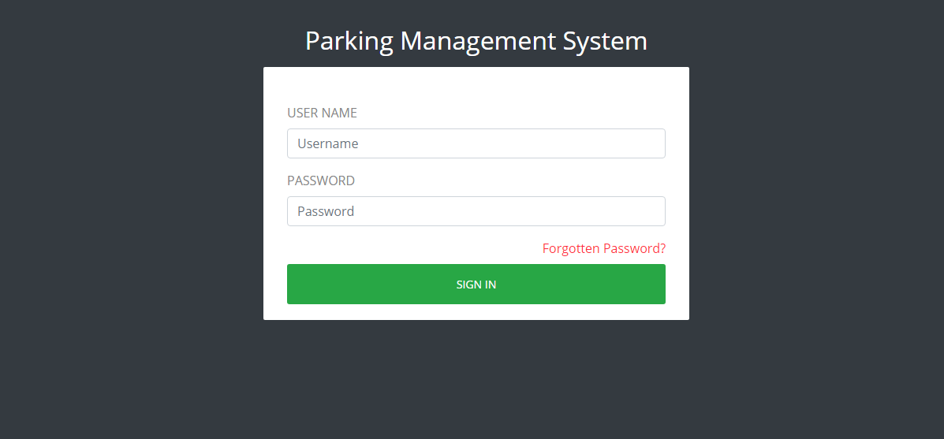

## 3.2 Dashboard

To view the entries of vehicles of last 7 days.

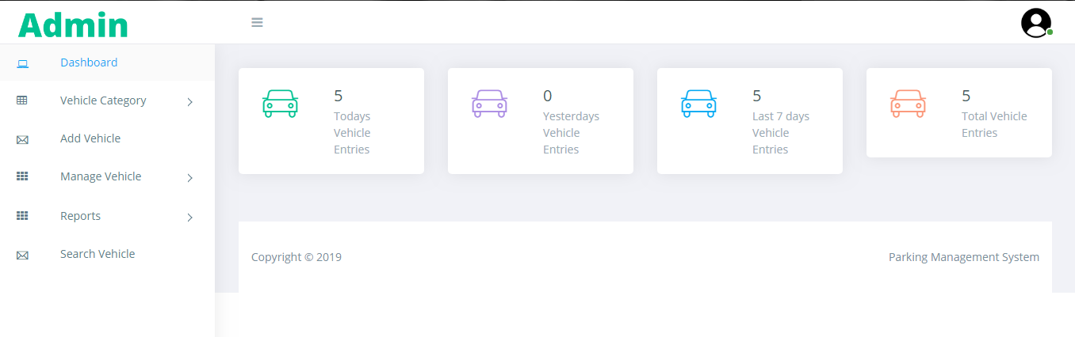

3.3 Vehicle Category

To add category of vehicle

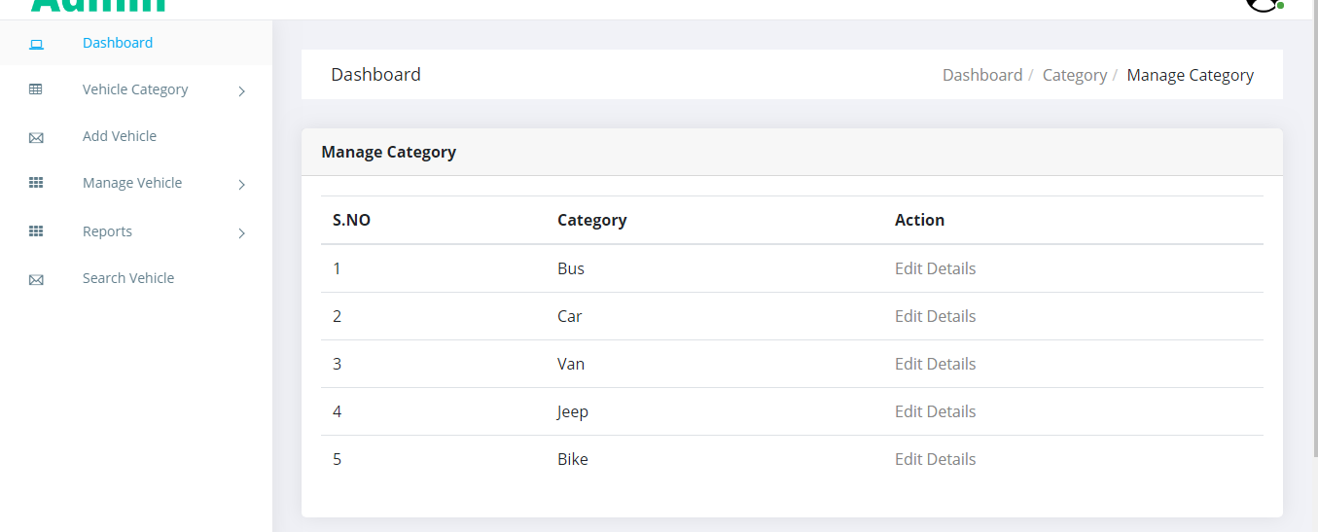

## 3.4 Vehicle Registration

To Register parking lot for a vehicle

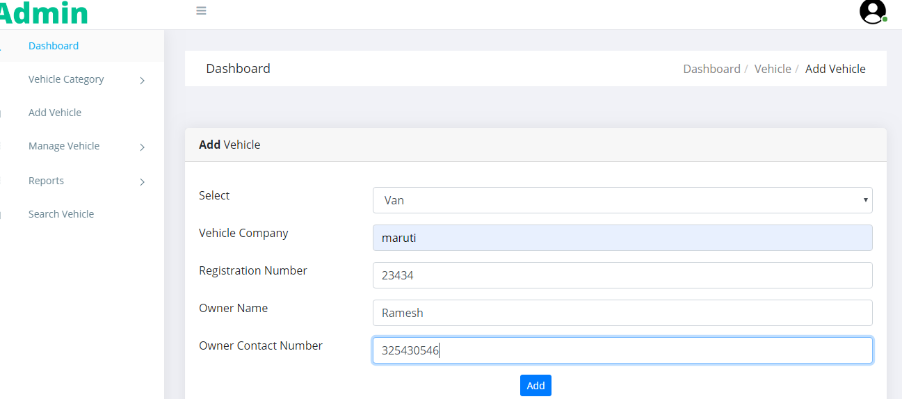

## 3.5 Outgoing vehicle

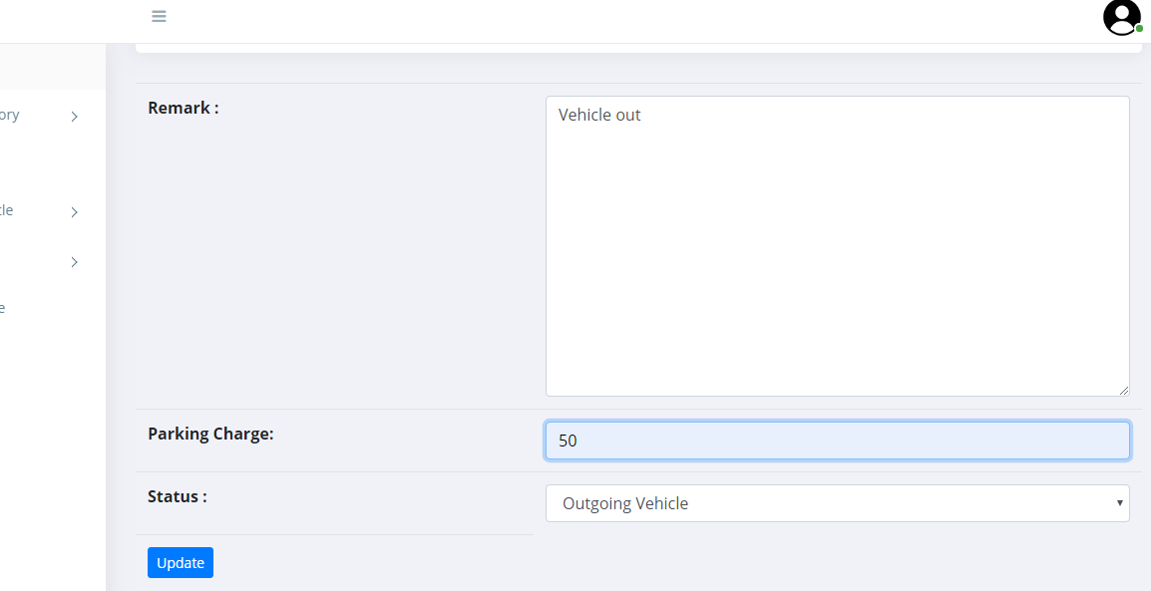

## 3.6 Print Receipt

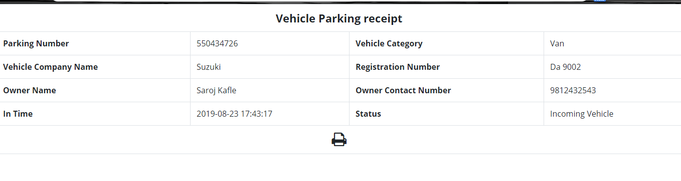

## 3.7 Search vehicle by parking number

## 

## 3.8 Change password

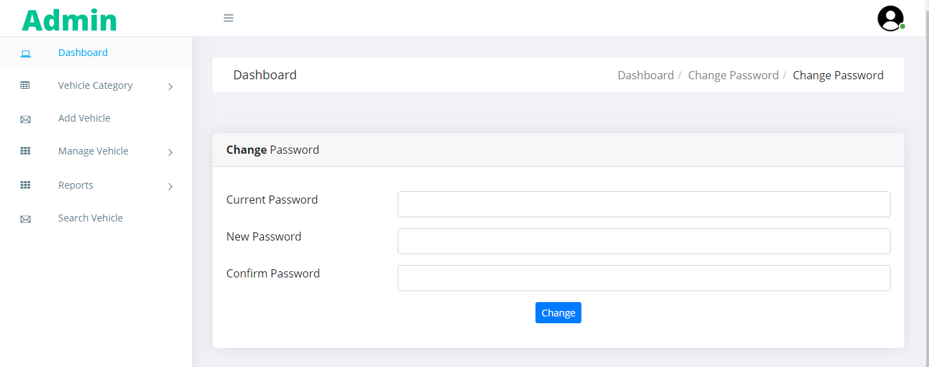

# CHAPTER 4

# CONCLUSION

The system developed is simple, user-friendly and faster. The system provides a systematic way of reserving the parking space for the user and allowing user to choose specific time of parking and also viewing the total fees of parking lot.